GPL32XXX Library MakeTool
- Execute CommandLineEntry.exe in the folder .\trunk\tools\make_tools
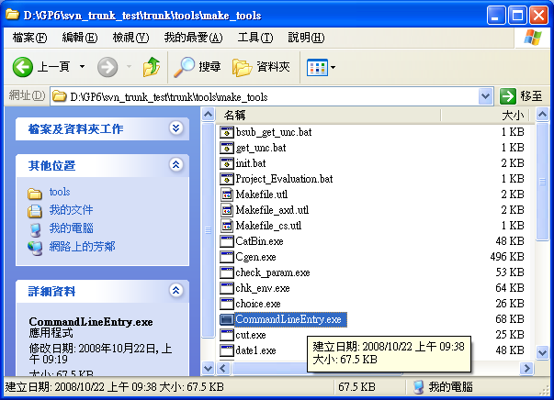

- Configure Config.ini
Copy the file Config.ini to the individual project folder and edit required libraries accordingly (for example, ..\trunk\project\my_demo). Each module name should be the same with its associated folder. Users can configure the required libraries by applications. Config.ini is as follows.
[Project]
PROJECTNAME=video_codec_demo
(note: gpmake will update project name automatically)
OPTIMAL_FLAG_DRV=-O1
OPTIMAL_FLAG=-O1
LIBA_OUT_PATH=liba (note: users can change the path for output libraries)
[MakeCfg]
APPLICATION=gpdemo
DRIVER_L1=cfc jpeg msc mscpro nand ppu scaler sdc spu usbD usbH xdc
DRIVER_L2=nand_flash usb_host
GPLIB=bmp fs gif gpzp jpeg post_processing ppu spu storages
GLOBAL=os
ObjDir=obj
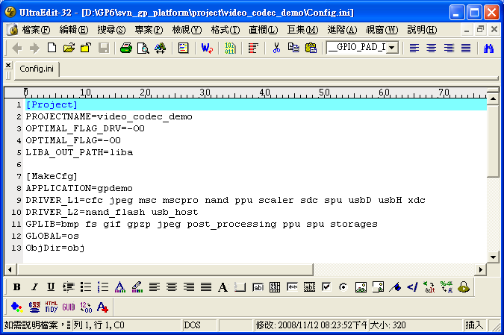

- Click right button of the mouse on the ..\tools\make_tools folder on the associated path. And then execute “Command Mode Entry”
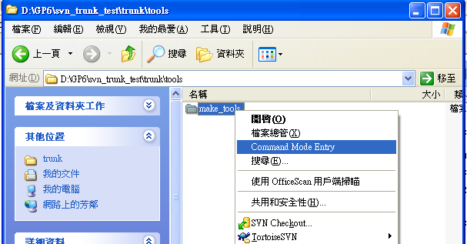
- Initialize gpmake tool. Enter “init” or “init ads” if ADS is used or enter “init cs” if CodeSourcery is used.
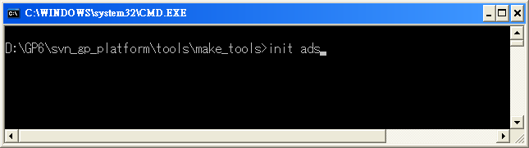
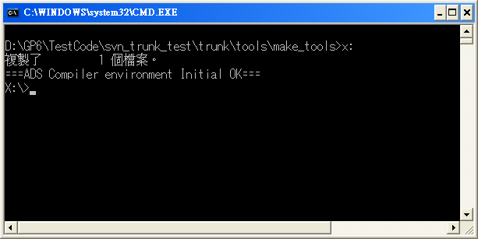

- Then DOS switches to disk X. Users need to go to the corresponding project folder where Config.ini locates and then enter “gpmake” to configure the environment according to Config.ini. Go to the selected project folder and execute “gpmake”
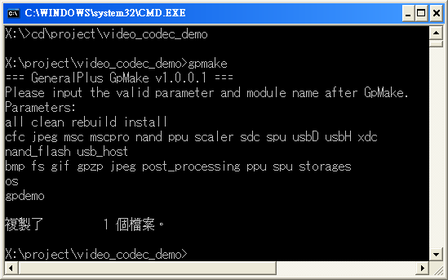

Parameters for gpmake:
all: to build all libraries which are defined in Config.ini
clean: to clean all libraries which are defined in Config.ini
rebuild: to clean and then build all libraries which are defined in Config.ini
install: to configure the environment for gpmake. Once Config.ini is modified during execution of gpmake, “gpmake” or gpmake install” needs to run again in order to meet modified Config.ini.

- Build a library from a designated module.
gpmake [individual module]
It will clean the existed library first and then build a new one.
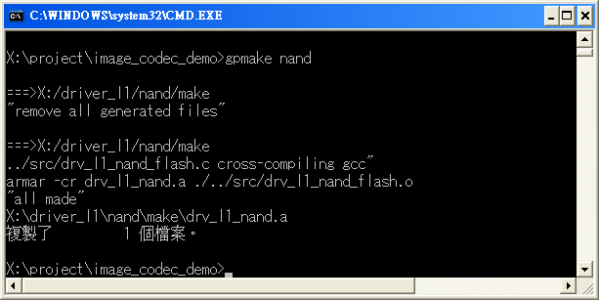

- Build user-defined library which originally is not part of gp_platform. Users need to copy their own source & head files to [src] and [inc] under ..\trunk\application\gpdemo.
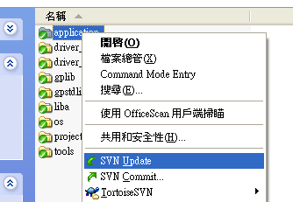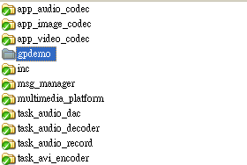
Then follow step1~step6 to make user-defined library. Afterward, users only need to rename gpdemo.a to a preferred library name.

